**Management System API (Dot Net)**

Ref 1 :

* Install “Sql Client” for database connection.

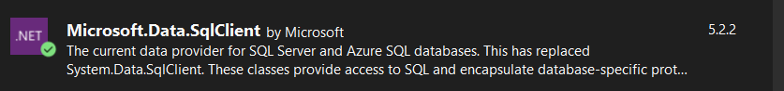

* It is used for use keyword “SqlConnection” for open sql connection in local database.

Ref 2 :

* Install “Dapper” for get multiple parameters



* It is Used for get multiple parameters for sql procedure.

Ref 3:

* Get Data from Appsettings.json

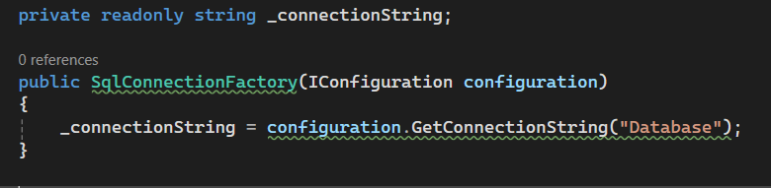

Ref 4 :